TPL Inventory Documentation:

Login Page: Project 🡺 Src 🡺 Components 🡺 Authentication 🡺 Login 🡺Login.jsx 🡺 API Data

1. Using useStates and useNavigation from React packages get the data from API’s.
2. A function “handle Submit” is used to with a button Named “Log in”.
3. A form in return segment submit and execute a function named “handle Submit” in which data from API is called.
4. After getting the Token successfully store in in to the local storage.
5. Navigate or redirect the page to the Next URL of dashboard.
6. Two inputs “user name or email & password” get from the user using input fields in return segment and sent it to the database from API.

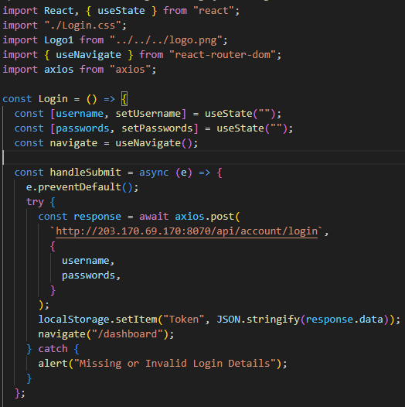

1. Import “axios” from “axios” package to fetch and send data form & to database.
2. Async Await is use to wait the compiler from execution of code till the data is get form API.
3. In the return segment a logo in imported from the directory.
4. Bootstrap classes like “container”, “row” and “card” are used to manage CSS and grid system.
5. Also a form is used to submit data get by the user send data to the database.

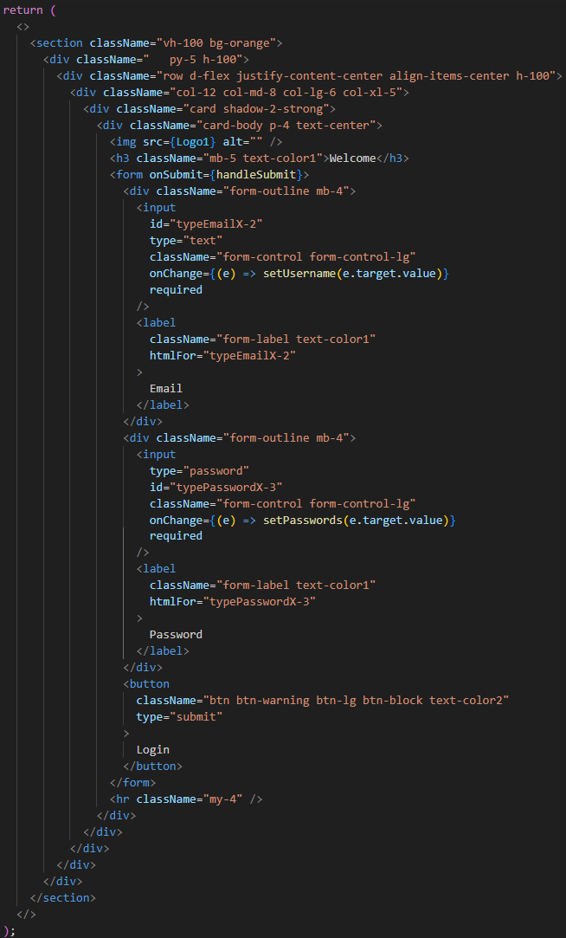

Login Validation: Project 🡺 Src 🡺 Components 🡺 Authentication 🡺 Login 🡺 Loginvalidation.jsx 🡺 token verification

1. This component ensure that token exist or not, with this component page with automatically redirect to the login page or dashboard according the existence of the token.
2. Using useEffect we just set a component validation which verifies either taken exist in local storage or not.
3. Props send to the App.js component and after verification routes decides to navigate in the checked and verified route with the help of useEffect using token.

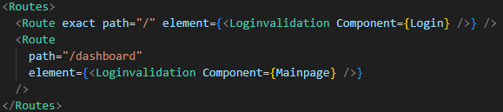

1. If token exist page redirects to the next page which is dashboard otherwise it navigates itself to the Login page.

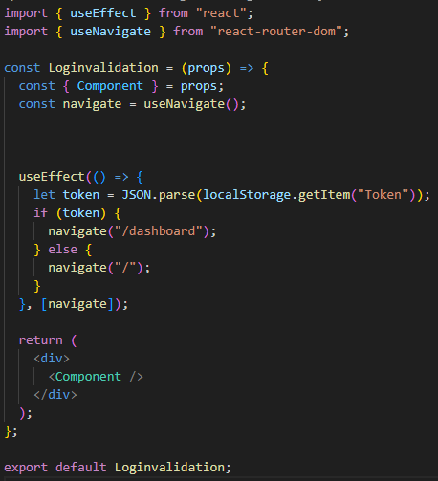

Login Validation: Project 🡺 Src 🡺 Components 🡺 Authentication 🡺 Changepassword 🡺 Changepassword.jsx 🡺 API Data

1. To change password of the user we need a user id to send data to that particular database of that user.